**Team Integration (Reusable Component)**

**Objective: Microsoft teams’ integration with Mendix Application.**

1. **Microsoft’s Graph Connector -** Microsoft Graph is the gateway to data and intelligence in Microsoft 365. The Microsoft Graph Connector enables you to connect your Mendix app to your Microsoft 365 environment through the Microsoft Graph API and enhance the experience of your users. Use the Graph Explorer to learn what you can do and extend the module with your own ideas. [Microsoft Graph Connector](https://marketplace.mendix.com/link/component/117007) .
   1. Created a new Project ‘POC_TeamsIntegration’ on Mendix studio Pro (support Mendix version 8.12 or higher).
   2. We need to install some required modules from the Mendix Marketplace -
      * Encryption module
      * NanoflowCommons module
      * CommunityCommons module

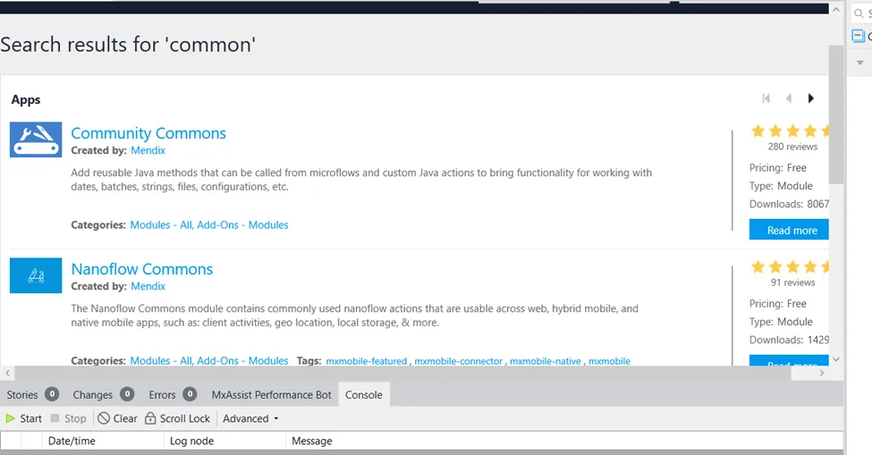

* 1. Downloaded and configure ‘Microsoft’s Graph Connector’ from market Place in our Project .  
     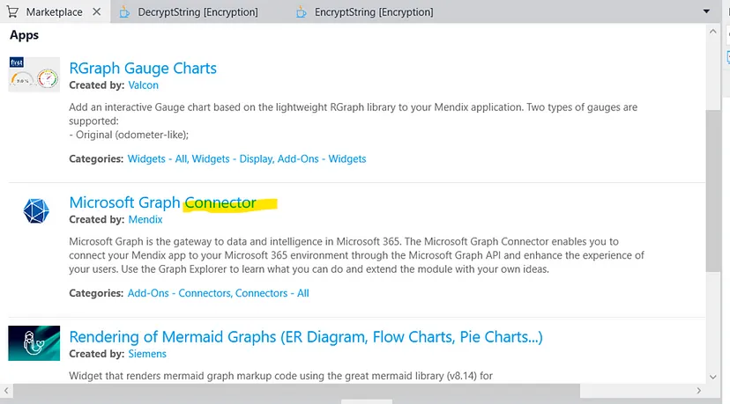
  2. Add the snippet named ‘Snip_Authentication_Overview’ to a page accessible to you. Run the App and check.  
     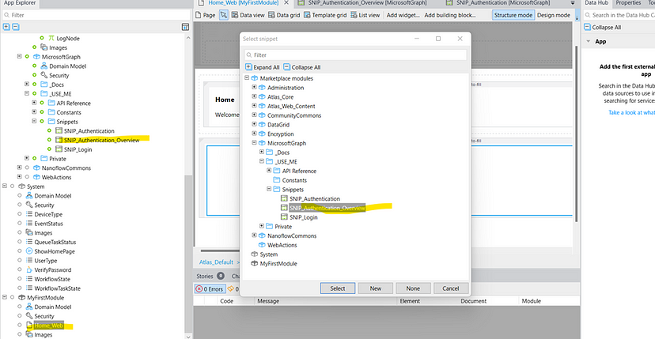  
     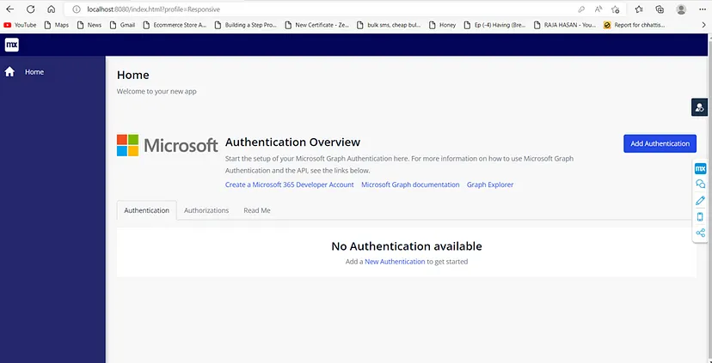
  3. Register here <https://developer.microsoft.com/en-us/microsoft-365/dev-program> for a Microsoft Azure Account.
  4. Once you’ve registered, please log in to the [Azure Portal.](https://azure.microsoft.com/en-in/get-started/azure-portal/) Azure Portal Dashboard should be display like bellow -   
     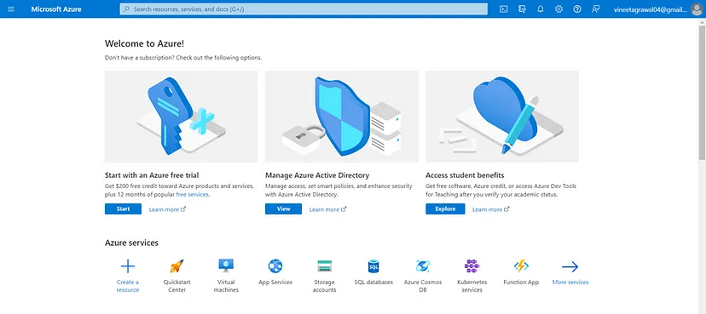
  5. Once you are logged in, please search ‘**Azure Active Dictionary**’ and click to open.
  6. Click on **App Registration** and click on **New Registration once** redirected. Register your app in Azure AD.
     + Name: Provide any suitable name.
     + Supported account type: You can choose as per your requirement.
     + Redirect URI: <http://localhost:8080/oauth/v2/callback_azure>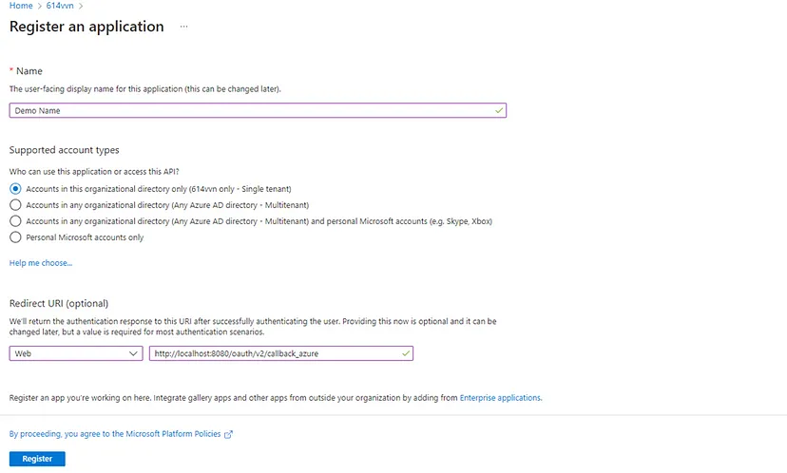  
       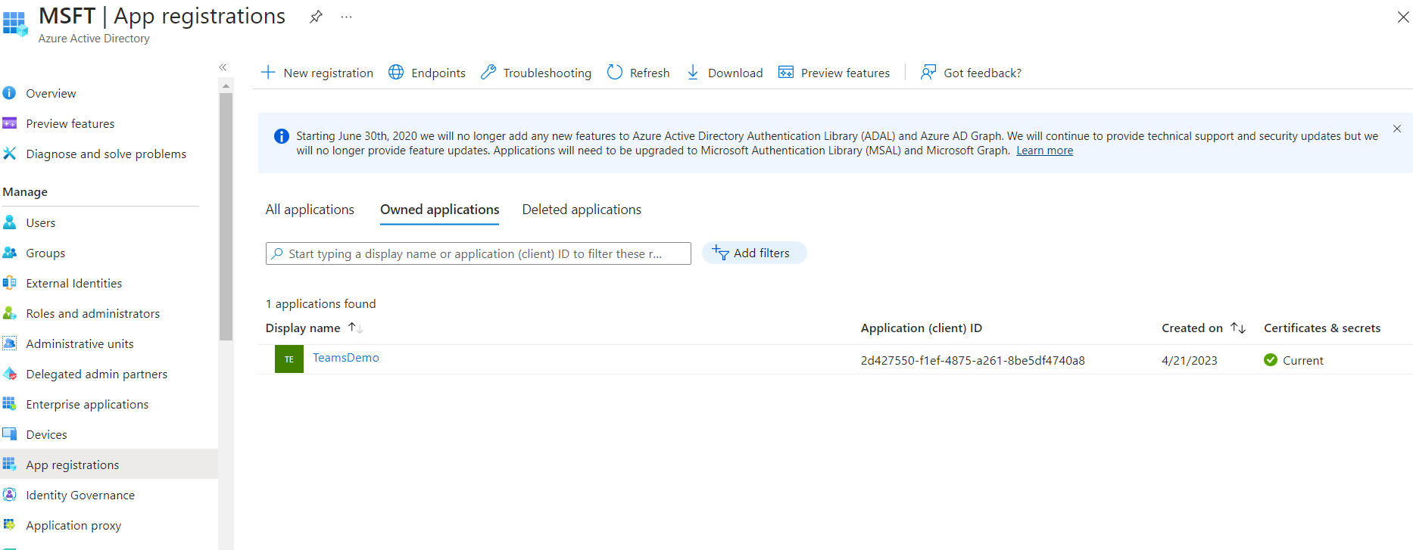
  7. After registration, you will see all the details required to complete the configuration of your app:  
     1. Application ID  
     2. Tenant ID  
     3. Client Secret - Click on ‘Add a Certificate’ and then click on ‘New Client Secret’ to create a new client secret. (**need to use Value and not ID in our application.**)  
     4. Redirect URI  
     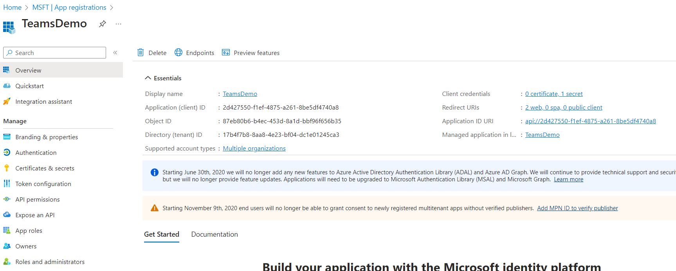

**Configure Mendix App –** now we have all the details and can continue with configuring our Mendix app.

* 1. Run the App and click on Add Authentication button .  
     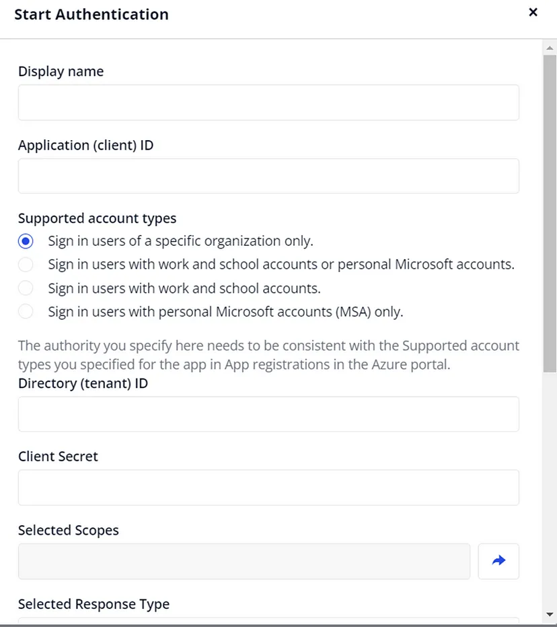
  2. Fill the Details listed -
     1. Display Name — any name can be provided
     2. Application ID — application ID in Azure Portal
     3. Tenant ID — tenant ID in Azure Portal
     4. Client Secret — client secret in Azure Portal
     5. Selected Scope — four scopes (one permission provided by default, the other permission you can add on ‘Meta Data’ in the last pop-up.
     6. Selected Response Type — code
     7. Selected Response Mode — query
     8. Prompt — consent
  3. Now click on ‘**Get Authorization as User**’.
  4. Next you will redirect to Consent Page and you need to Accept it.  
     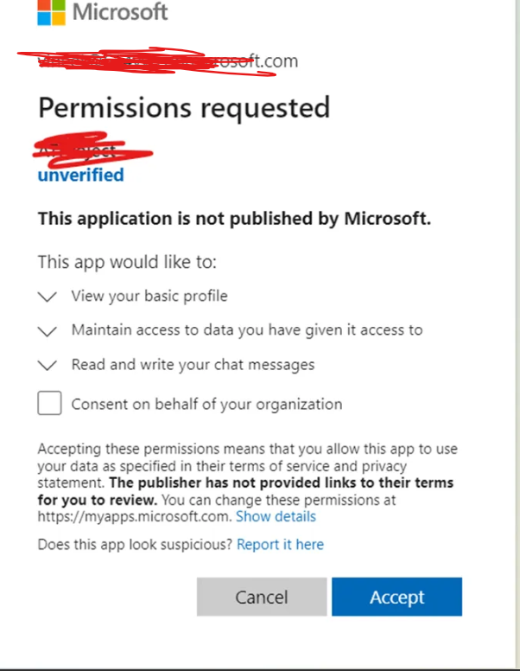
  5. Now click on View Resource in Option button. 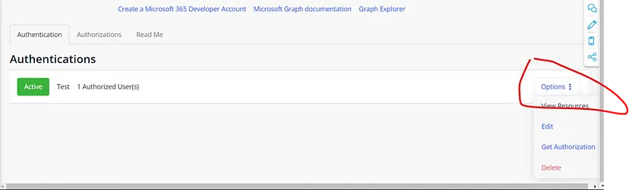
  6. You can now make use of all the services provided by this connector.   
     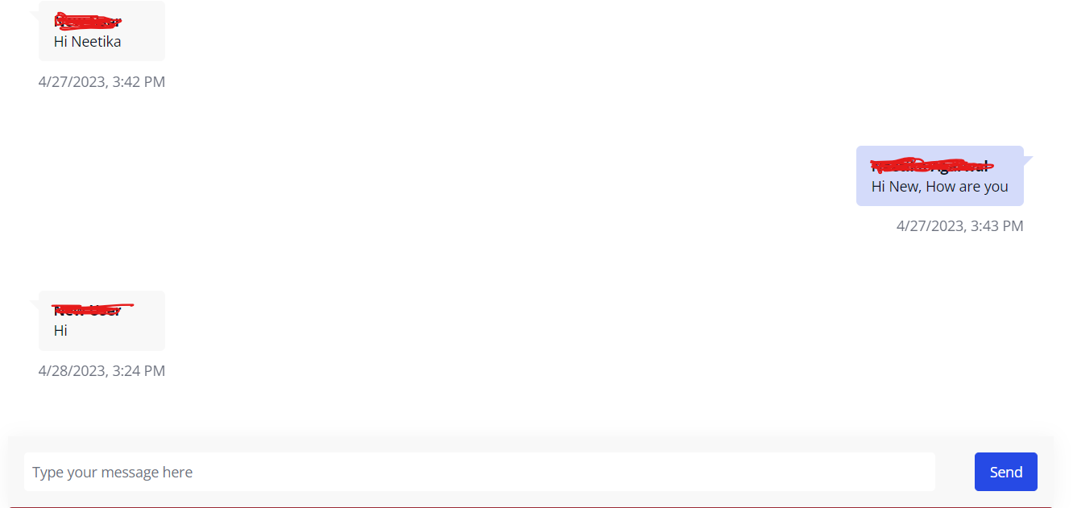

Note —

* You need to provide the correct scopes for using services, some commonly used scopes are: <https://learn.microsoft.com/en-us/graph/permissions-reference>
  + **Mail** — sending and receiving mail
  + **Teams** — read and write on Teams channel
  + **Chat** — one-to-one chat is supported
  + **Calendar** — you can access the calendar and schedule meeting invites
  + **Files** — you can access all Microsoft files.
* Make sure your account should have **Microsoft 365 E5 Developer** Licenses.